**Thanthai Periyar Government Arts and Science College. Trichy -620023.**

**Department of Mathematics**

Team No: 15

NM ID: NM2023TMID02625

Project Title: Estimation of Business Expenses

Team Leader: Arun kumar. R

Team members:

1. Arulselvi. R
2. Divya. P
3. Kannika. C
4. **Introduction**

Estimation Of Business Expenses

1.1 Overview

This report deal's into the fascinating realm of business expenses and provides a visual exploration of the various expenditures incurred by different businesses. It showcases the distribution of expenses, identifies key cost drivers, and highlights areas of potential optimization or concern. The visual representations allow for intuitive analysis, facilitating a deeper understanding of expenditure patterns and their implications for business performance.

1.2 Purpose

Decision-makers, financial analysts, and stakeholders can gain valuable insights into the financial health of businesses, identify areas of inefficiency or opportunity, and make informed decisions to optimize resources and drive growth. To Extract the Insights from the data and put the data in the form of visualizations, Dashboards and Story we employed Tableau tool.

1. **Problem Definition & Design Thinking**

2.1. Empathy map

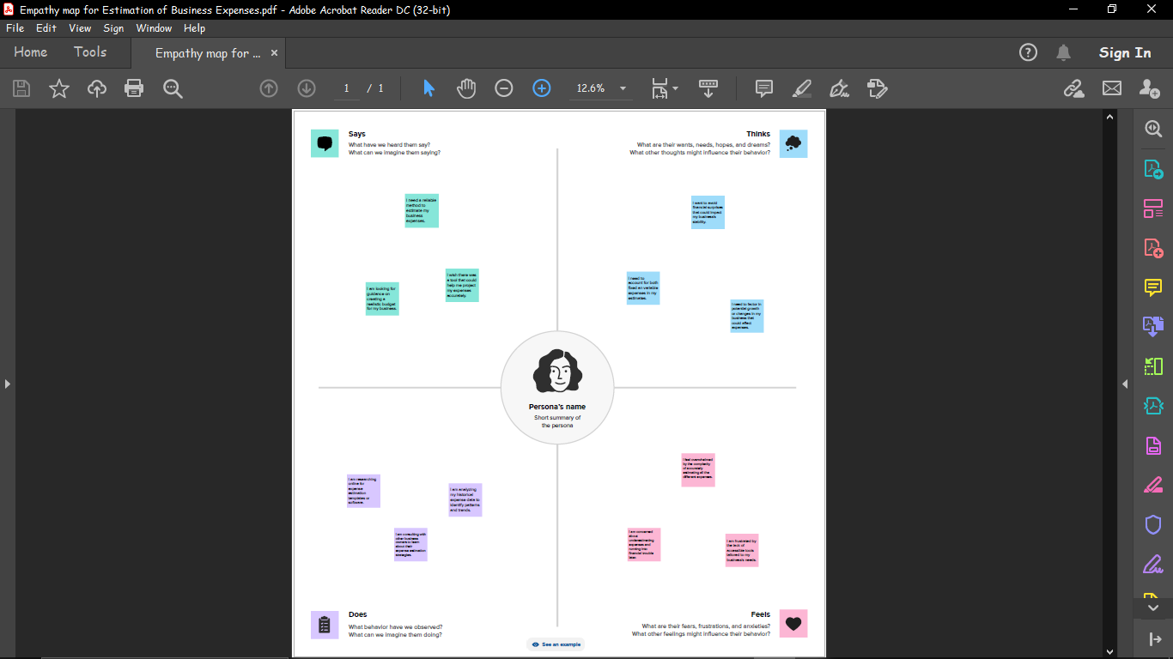

€

2.2. Ideation & Brainstorming Map

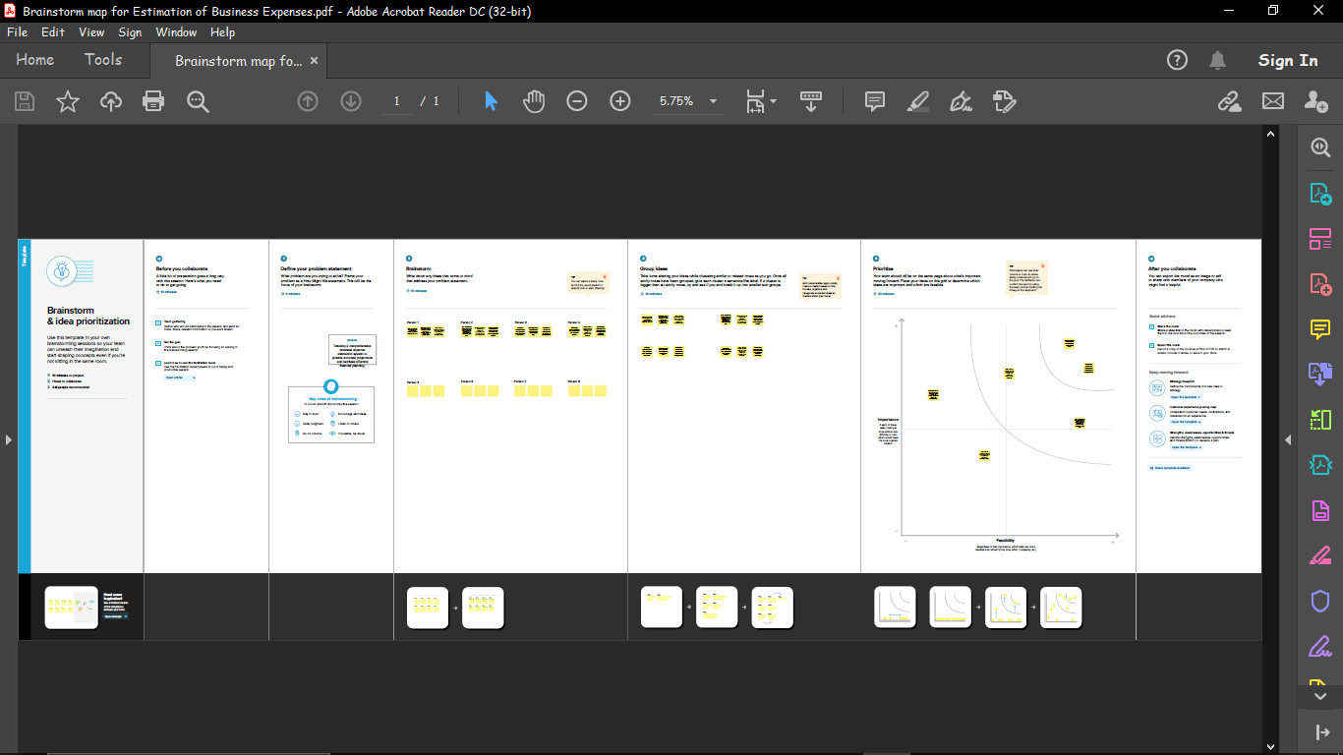

1. **Result**

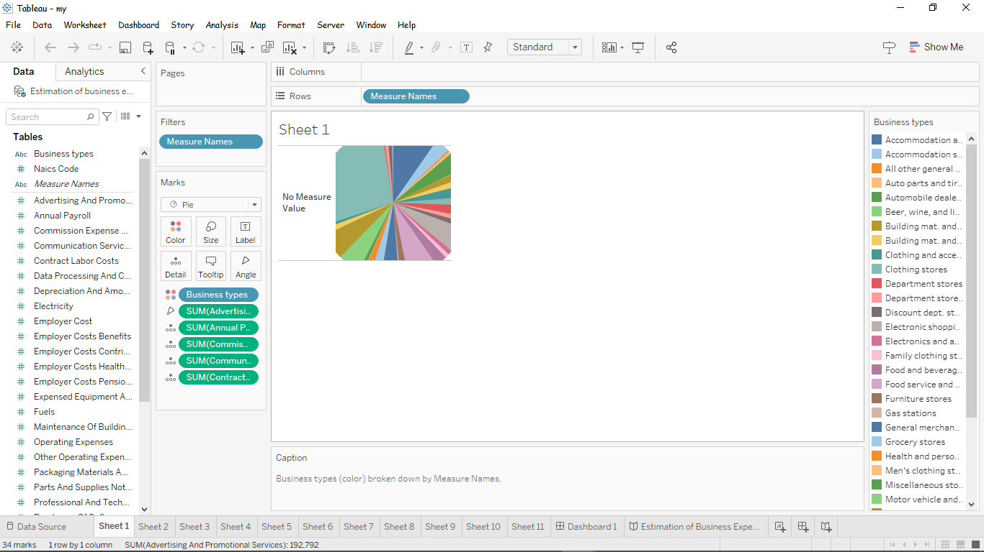

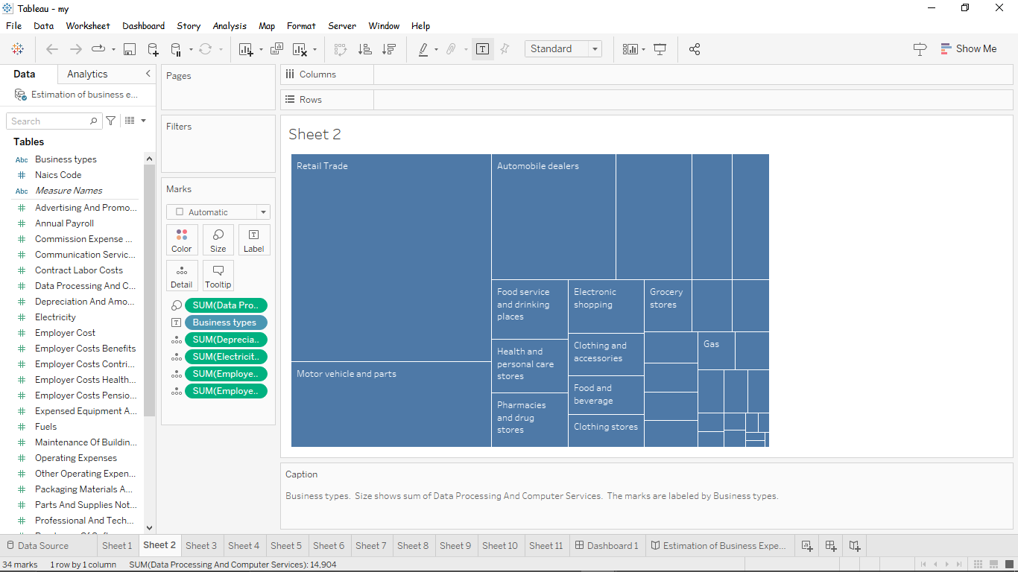

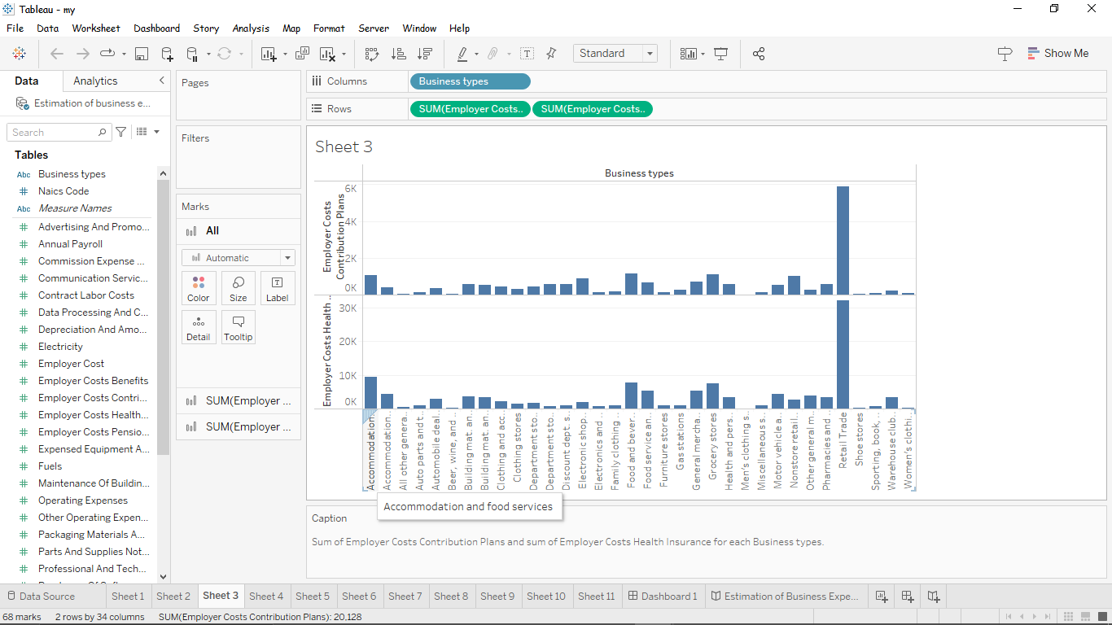

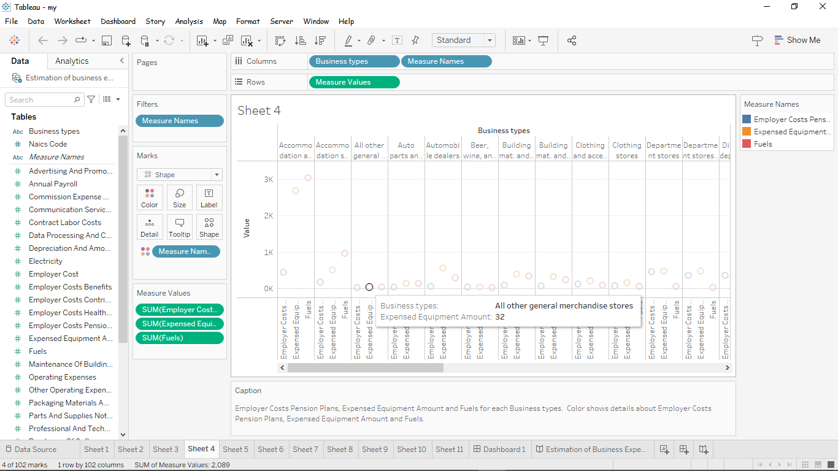

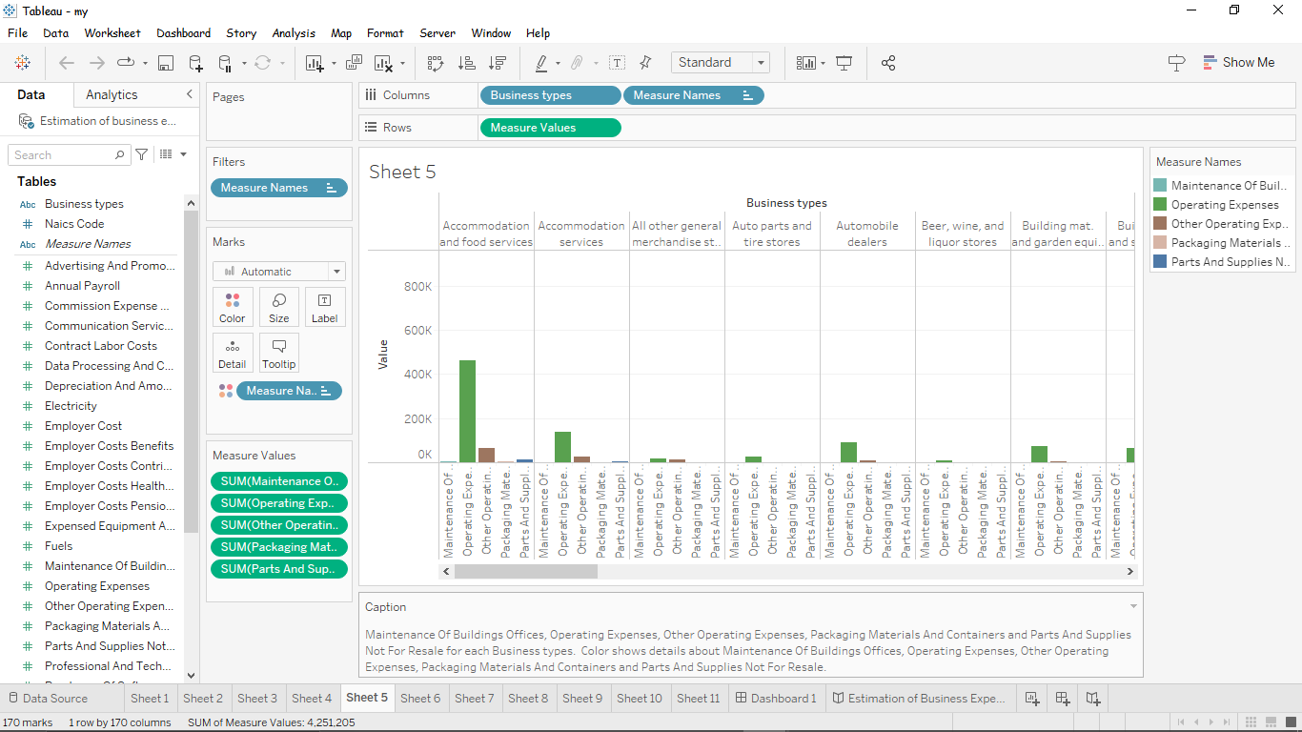

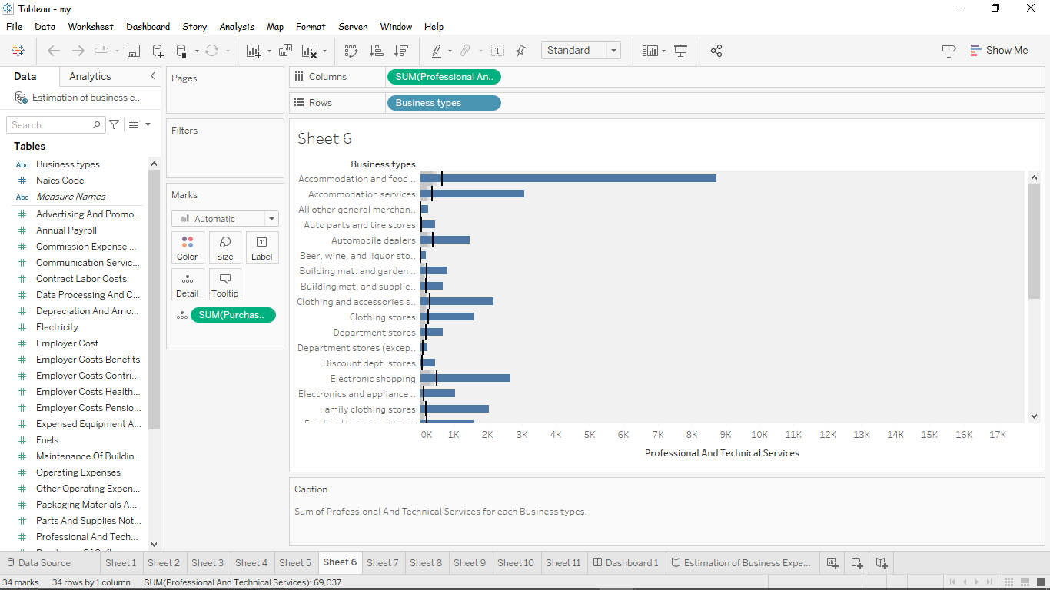

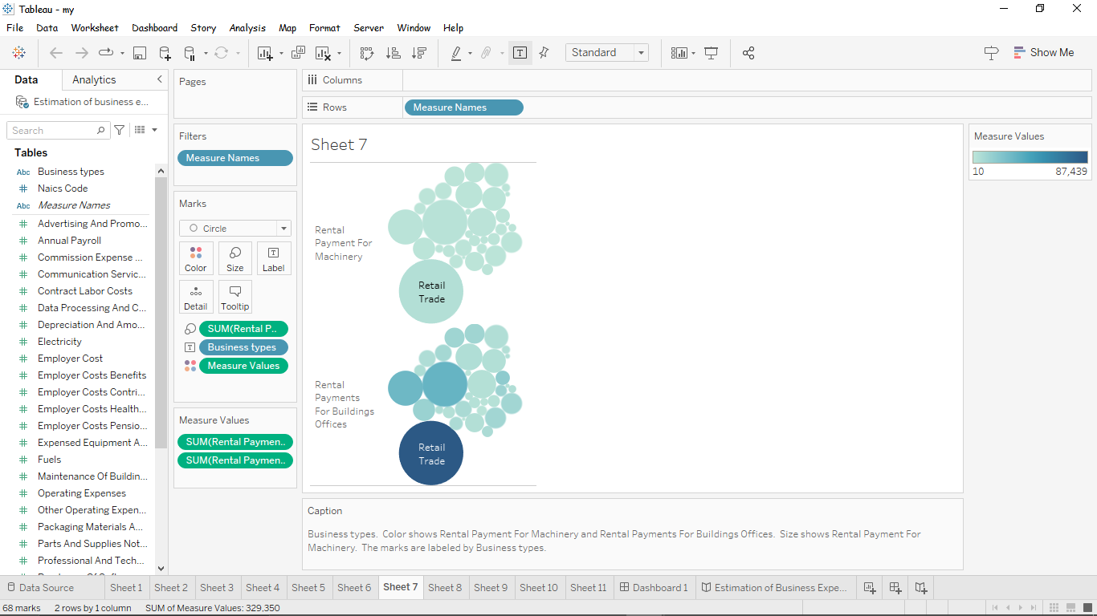

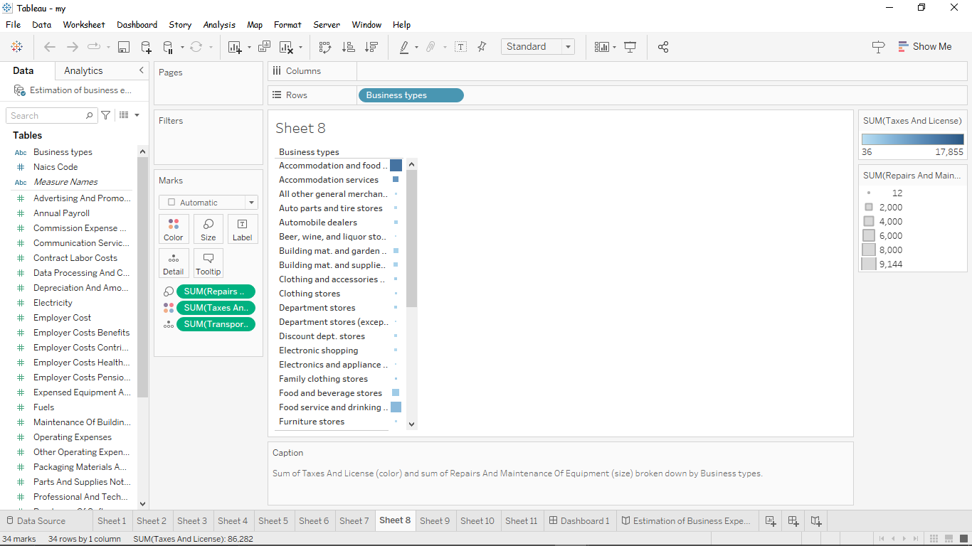

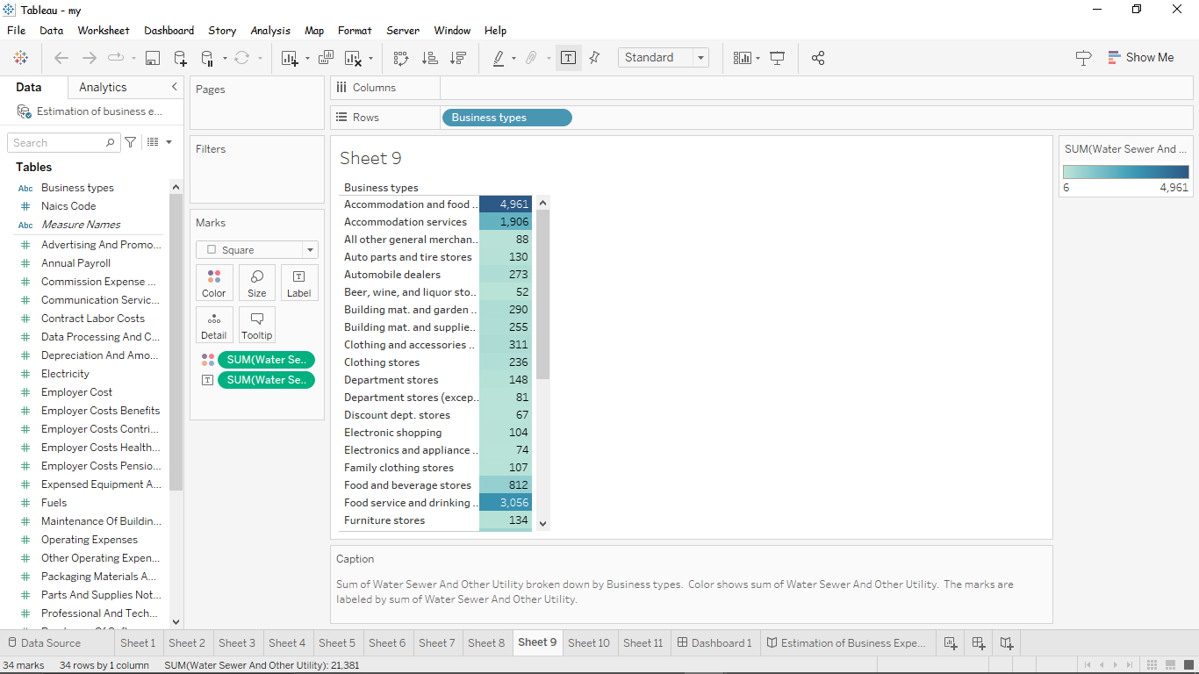

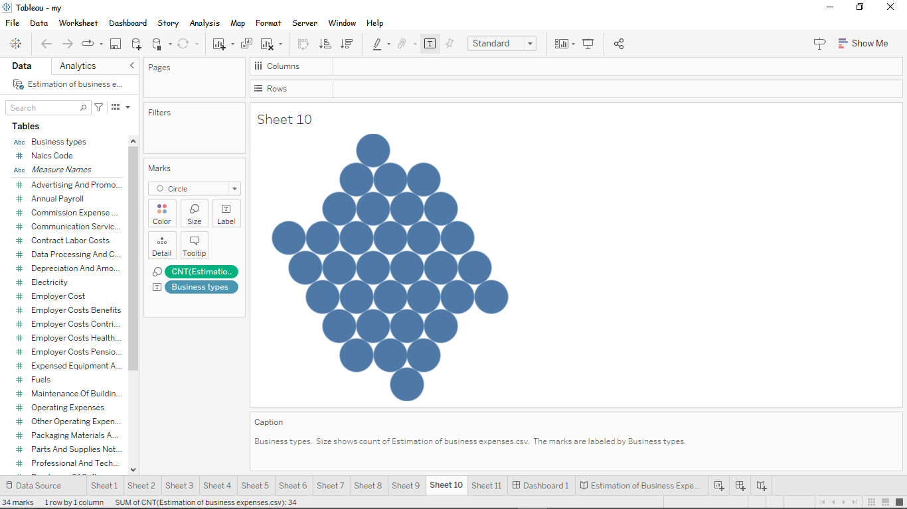

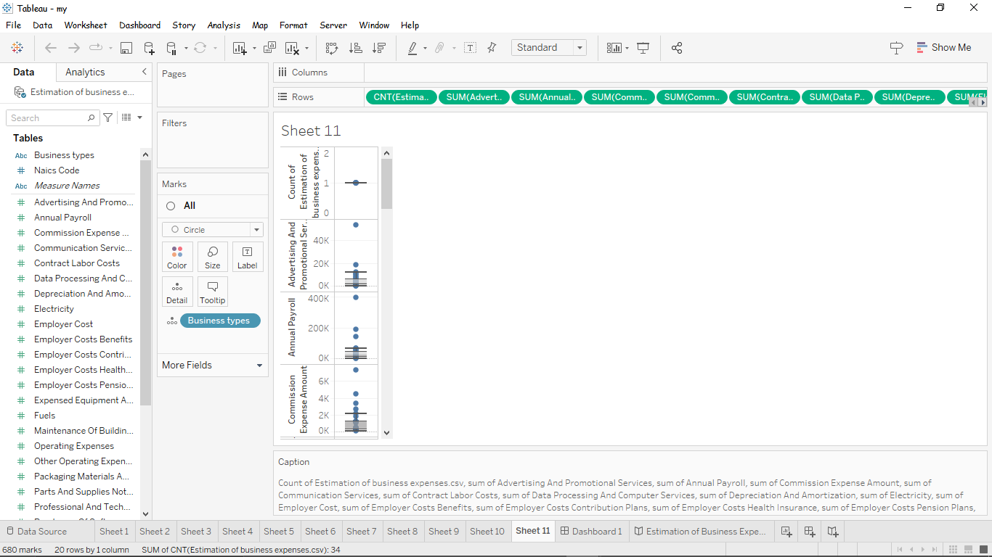

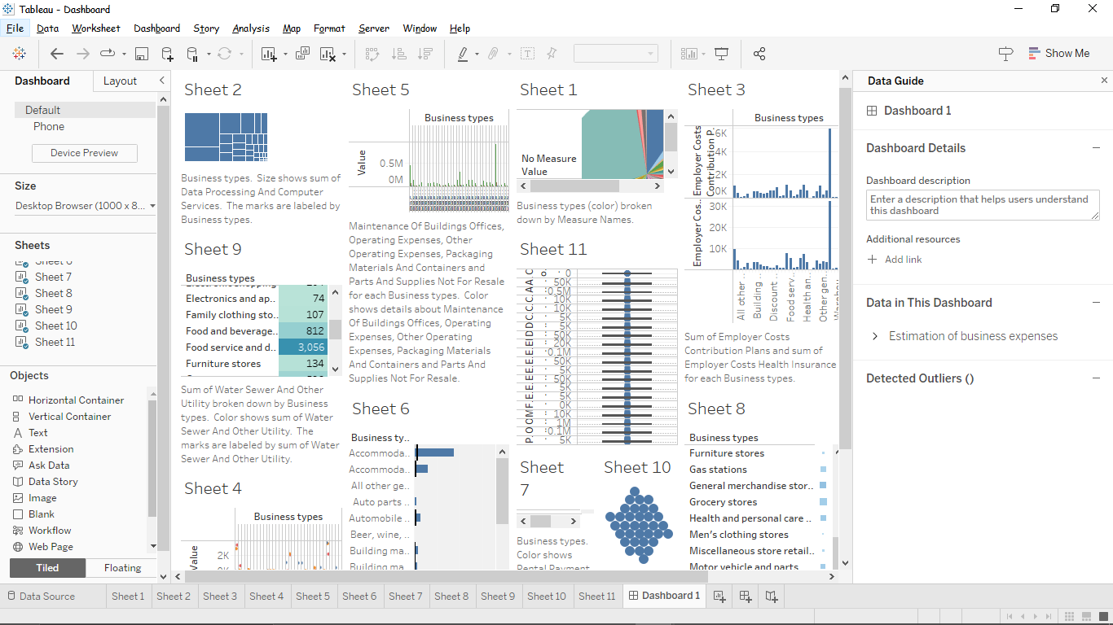

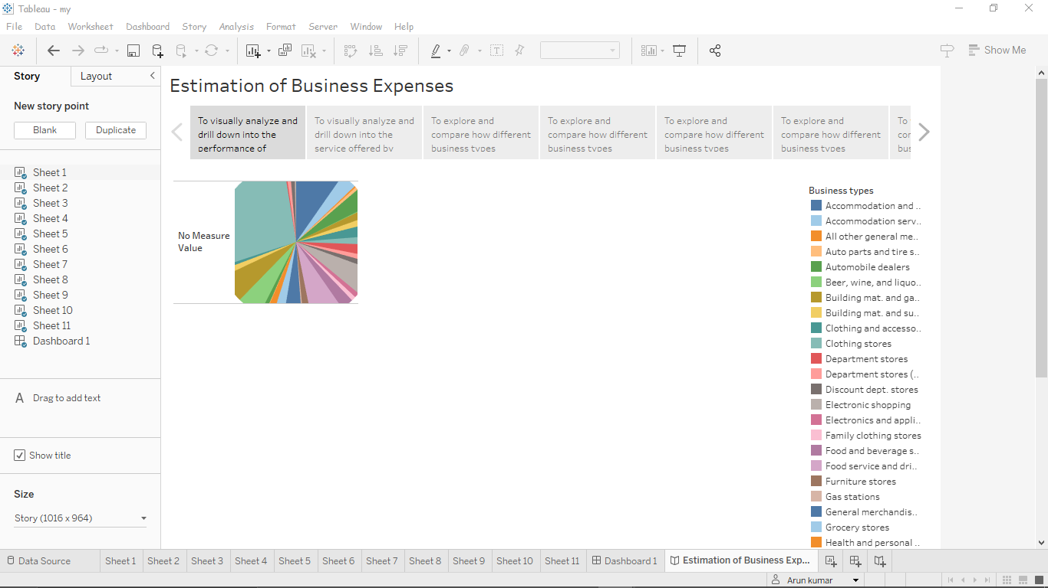

1. **Advantages & Disadvantages**

Understanding a company’s expenses helps a company to run its business well. Some expense categories are tax-deductible, helping a company reduce its tax liability. The disadvantages of bottom-up estimating include the high level of detail required, the need for expert opinion, the time-consuming nature of decomposing a project, and the inherent costs associated with the additional time and team members required to generate such an estimate.

1. **Applications**

Business expenses are costs associated with running a company. When we know all of a company’s expenses, we can create a more accurate budget and track spending. Expenses are also a part of a company’s income sheet. Business’s expenses are used to calculate a final net profit.

1. **Conclusion**

Not only are estimates essential to winning new business, they also determine project budget, job schedule, and how we manage our resources, and ultimately, how much we invoice clients. Estimates help businesses give price quotes to customers before the sale can take place.

1. **Future Scope**

Calculating the startup costs for small business can be useful to request funding, attract investors, and estimate when we’ll turn a profit.